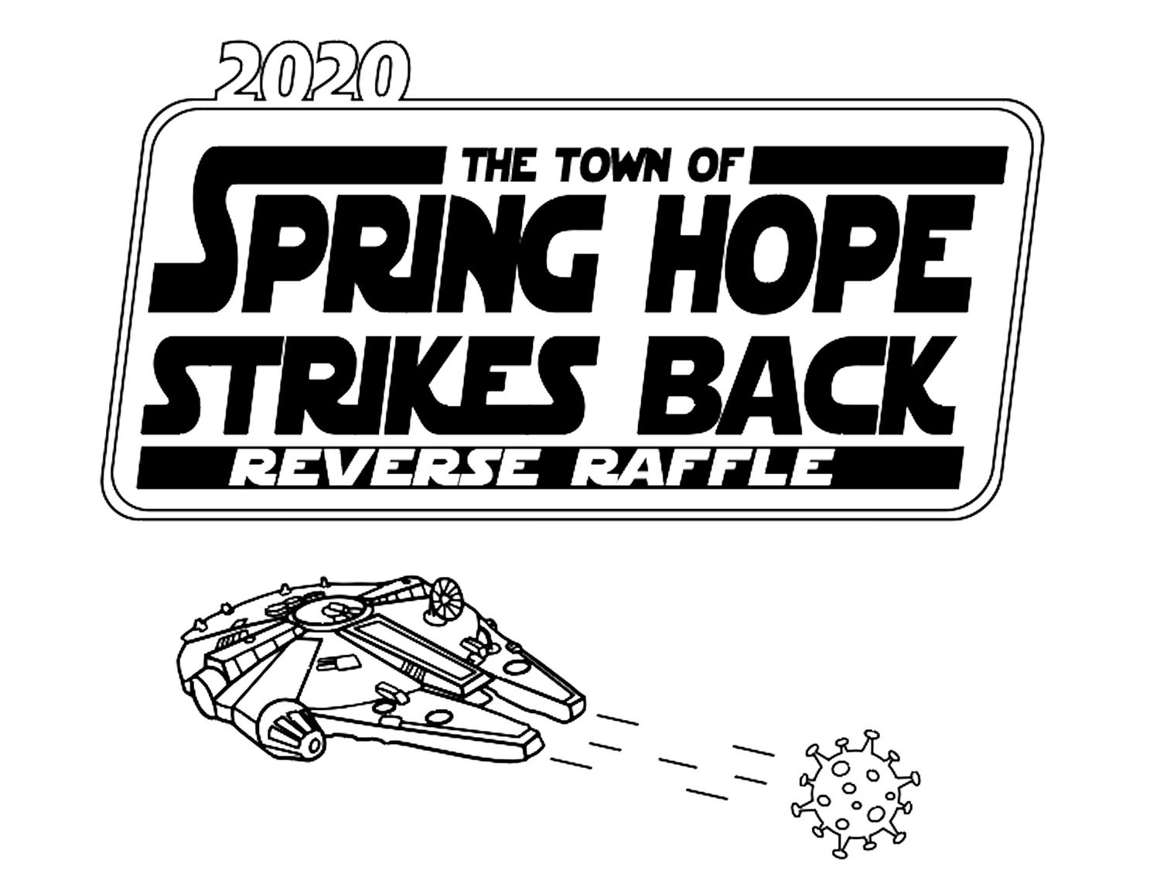
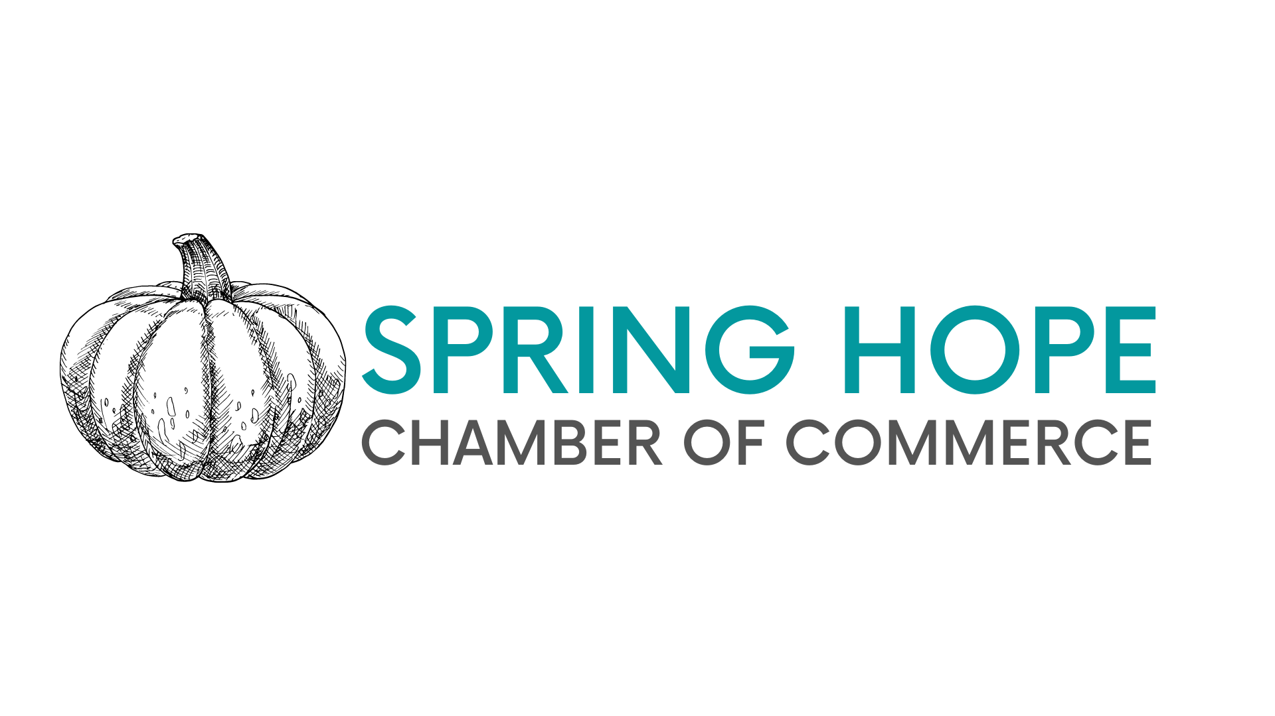
Spring Hope Strikes Back
Grant Application
Organized by the Spring Hope Area
Chamber of Commerce

Deadline for Submission:
Friday, July 31, 2020 8pm EST
Email application to: SpringHopeChamber@gmail.com

Grant Eligibility: All conditions must apply.
- Must be a small business (250 employees or less)
- Less than $750k in annual revenue.
- Local to Spring Hope Area (Within town limits or Extra Territorial Jurisdiction; “ETJ”)
OR current Spring Hope Area Chamber Member as of June 1, 2020.

Business/organization will be verified with the State of North Carolina’s Secretary of State corporation database
____________________________________________________________

Business Name:______________________________
Date of Incorporation/Formation: _________________

Business Address:
Street:______________________________________________
City, State, Zip________________________________________

Business Principles/Officers
-_____________________
-_____________________
-_____________________

Organization Type: (LLC, Corporation, Partnership):__________________

For Profit ____ or 501(c)3 Non-Profit ____

Estimated Annual Revenue: $________________

Estimated lost revenue due to Covid-19 restrictions: $_________________

Did your business suspend operation under NC Executive Order 121? (Y/N) _______

Was/is this business your primary household income? (Y/N) ______

Under current guidelines, how is your business performing compared to pre-Covid restrictions? (attach separate sheet if necessary)

Is your business at risk of closure or bankruptcy due to COVID-19 restrictions? (Y/N) __

Request grant value: ______________ ($1000.00 max grant benefit)

Signature______________________________

Date__________________________________

DISCLAIMER: The Spring Hope Area Chamber of Commerce reserves the right to award or decline any application for failure to meet the above qualifications. An independent panel will review and advise the Chamber Board of Directors as to grant awards and associated grant value. All information provided via this form will be held in the highest confidence by the Chambers Qualification panel and the Independent Review panel.

